**Sample Written examination # 1 – By Jack Graffeo**

**November 2023**

**Reading time: 15 mins**

**Writing time: 2 hours**

**QUESTION AND ANSWER BOOK**

**Structure of the exam**

|  |  |  |  |  |  |
| --- | --- | --- | --- | --- | --- |
|  | *Section* | *Number of questions* | *Number of questions to be answered* | *Number of marks* |  |
|  | A | 10 | 10 | 60 |  |
|  | B | 4 | 1 | 20 |  |
|  |  |  |  | Total 80 |  |

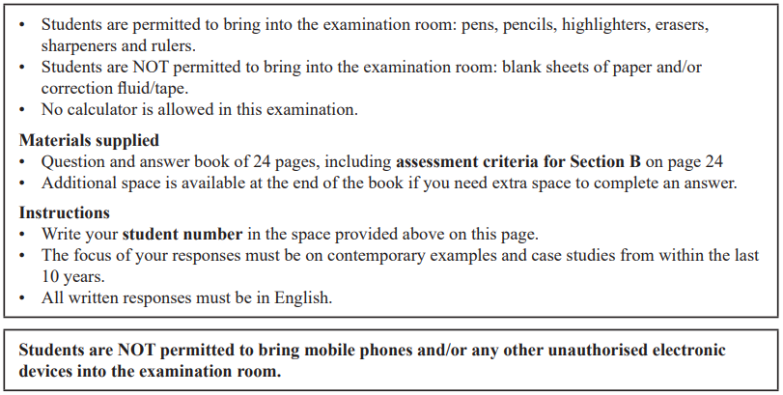

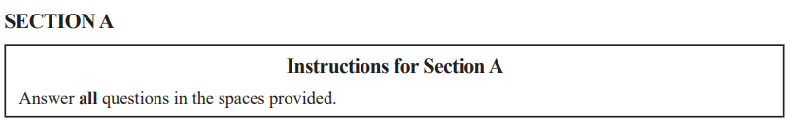

**Question 1** (5 marks)

Analyse the impact of one contested border on the sovereignty of a state.

|  |
| --- |
|  |
|  |
|  |
|  |
|  |
|  |
|  |
|  |
|  |
|  |
|  |
|  |
|  |
|  |
|  |

**Question 2** (4 marks)

Explain how globalisation impacts the power of one non-state actor.

|  |
| --- |
|  |
|  |
|  |
|  |
|  |
|  |
|  |
|  |
|  |
|  |
|  |
|  |

**Question 3** (6 marks)

Evaluate the extent to which the International Criminal Court (ICC) has successfully achieved its aims.

|  |
| --- |
|  |
|  |
|  |
|  |
|  |
|  |
|  |
|  |
|  |
|  |
|  |
|  |
|  |
|  |
|  |
|  |
|  |
|  |

**Question 4 (15 marks)**

One of the following Asia-Pacific states must be used as the focus of all responses to Question 4: Australia, China, Indonesia, Japan or the United States of America.

Selected Asia-Pacific state: ____________________________________________________

1. Describe one use of power this Asia-Pacific state has taken to maintain its sovereignty. (3 marks)

|  |
| --- |
|  |
|  |
|  |
|  |
|  |
|  |
|  |
|  |
|  |

1. Outline two differing interpretations of this Asia-Pacific state’s pursuit of international standing. (4 marks)

|  |
| --- |
|  |
|  |
|  |
|  |
|  |
|  |
|  |
|  |
|  |
|  |
|  |
|  |

1. Analyse the relative importance of this Asia-Pacific state’s use of military power and economic power in achieving economic prosperity. (8 marks)

|  |
| --- |
|  |
|  |
|  |
|  |
|  |
|  |
|  |
|  |
|  |
|  |
|  |
|  |
|  |
|  |
|  |
|  |
|  |
|  |
|  |
|  |
|  |
|  |
|  |
|  |

**Question 5** (3 marks)

Using one specific example, explain the term ‘ethics’ as it relates to the study of global politics.

|  |
| --- |
|  |
|  |
|  |
|  |
|  |
|  |
|  |
|  |
|  |

**Question 6** (4 marks)

From the list below, select one ethical issue that you have studied this year:

• human rights

• people movement

• development

• arms control

Ethical issue: _______________________________________________________________

Explain how one global actor’s response to this ethical issue demonstrated a pursuit of justice under international law.

|  |
| --- |
|  |
|  |
|  |
|  |
|  |
|  |
|  |
|  |
|  |
|  |
|  |
|  |

**Question 7** (8 marks)

From the table below, select a debate relating to another ethical issue that you have studied this year. The ethical issue selected must be **different** from the one selected in Question 6.

|  |  |  |
| --- | --- | --- |
| **Ethical issue** |  | **Debate** |
| Human rights | → | State sovereignty versus ‘Responsibility to protect’ |
| People Movement | → | Obligations to asylum seekers and other refugees versus national interests including border security |
| Development | → | Economic growth versus sustainable development |
| Arms control | → | Arms control versus disarmament. |

Ethical issue ________________________________________________________________

Analyse how two sides of this debate may be guided by different ethical perspectives.

|  |
| --- |
|  |
|  |
|  |
|  |
|  |
|  |
|  |
|  |
|  |
|  |
|  |
|  |
|  |
|  |
|  |
|  |
|  |
|  |
|  |
|  |
|  |
|  |
|  |
|  |
|  |

**Question 8** (4 marks)

From the list below, select one global crisis that you have studied this year:

**You must respond to the same global crisis in Question 8 and 9.**

• climate change

• armed conflict

• terrorism

• economic instability

Global crisis: _______________________________________________________________

Explain how one cause of this global crisis has been cyclical.

|  |
| --- |
|  |
|  |
|  |
|  |
|  |
|  |
|  |
|  |
|  |
|  |
|  |
|  |

**Question 9** (4 marks)

From the table below, select a key aspect related to a global crisis that you have studied this year. The global crisis must be **the same** as the one selected in Question 8.

|  |  |  |
| --- | --- | --- |
| **Global crisis** |  | **Key aspect** |
| Climate change | → | Methods of adapting to and reducing climate change |
| Armed conflict | → | Intervention |
| Terrorism | → | Non-state terrorism |
| Economic instability | → | Globalisation |

Explain how this key aspect challenges the effective resolution of this global crisis.

|  |
| --- |
|  |
|  |
|  |
|  |
|  |
|  |
|  |
|  |
|  |
|  |
|  |
|  |

**Question 10** (7 marks)

Select another global crisis that you have studied this year. The global crisis selected must be **different** from the one selected in Question 8 and 9.

Global crisis ________________________________________________________________

Evaluate the extent to which crisis diplomacy has supported the effective resolution of this global crisis.

|  |
| --- |
|  |
|  |
|  |
|  |
|  |
|  |
|  |
|  |
|  |
|  |
|  |
|  |
|  |
|  |
|  |
|  |
|  |
|  |
|  |
|  |
|  |

**SECTION B**

Write an essay on one of the following questions in the space provided.

Your response will be assessed according to the assessment criteria set out on the back page.

**Question 1** (20 marks)

‘While the process of globalisation does bring benefits to states, it also opens it up to challenges from other global actors.’ Discuss

**OR**

**Question 2** (20 marks)

Don’t do this question, unless you want to do bad on this exam.

**OR**

**Question 3** (20 marks)

Evaluate the extent to which global actor’s responses to two ethical issues reflect obligations outlined in international law.

**OR**

**Question 4** (20 marks)

‘The causes of global crises may be cyclical and the responses can at times exacerbate the original crisis.’ Discuss with reference to at least one global crisis.



|  |
| --- |
|  |
|  |
|  |
|  |
|  |
|  |
|  |
|  |
|  |
|  |
|  |
|  |
|  |
|  |
|  |
|  |
|  |
|  |
|  |
|  |
|  |
|  |
|  |
|  |
|  |
|  |
|  |
|  |
|  |
|  |
|  |
|  |
|  |
|  |
|  |
|  |
|  |
|  |
|  |
|  |
|  |
|  |
|  |
|  |
|  |
|  |
|  |
|  |
|  |
|  |
|  |
|  |
|  |
|  |
|  |
|  |
|  |
|  |
|  |
|  |
|  |
|  |
|  |
|  |
|  |
|  |
|  |
|  |
|  |
|  |
|  |
|  |
|  |
|  |
|  |
|  |
|  |
|  |
|  |
|  |
|  |
|  |
|  |
|  |
|  |
|  |
|  |
|  |
|  |
|  |
|  |
|  |
|  |
|  |
|  |
|  |
|  |
|  |
|  |
|  |
|  |
|  |
|  |
|  |
|  |
|  |
|  |
|  |
|  |
|  |
|  |
|  |
|  |
|  |
|  |
|  |
|  |
|  |
|  |
|  |
|  |
|  |
|  |
|  |
|  |
|  |
|  |
|  |
|  |
|  |
|  |
|  |
|  |
|  |
|  |
|  |
|  |
|  |
|  |
|  |
|  |
|  |
|  |
|  |
|  |
|  |
|  |
|  |
|  |
|  |
|  |
|  |
|  |
|  |
|  |
|  |
|  |
|  |
|  |
|  |

**END OF SECTION B**

**Extra space for responses.**

**Clearly number all responses in this space.**

|  |
| --- |
|  |
|  |
|  |
|  |
|  |
|  |
|  |
|  |
|  |
|  |
|  |
|  |
|  |
|  |
|  |
|  |
|  |
|  |
|  |
|  |
|  |
|  |
|  |
|  |
|  |
|  |
|  |
|  |
|  |
|  |
|  |
|  |
|  |
|  |
|  |
|  |
|  |
|  |
|  |
|  |
|  |
|  |
|  |
|  |
|  |
|  |
|  |
|  |
|  |
|  |

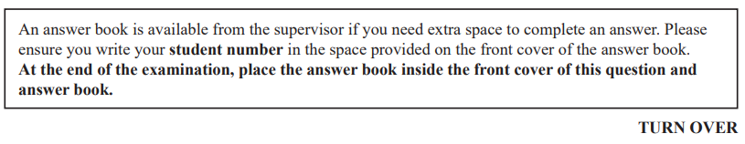

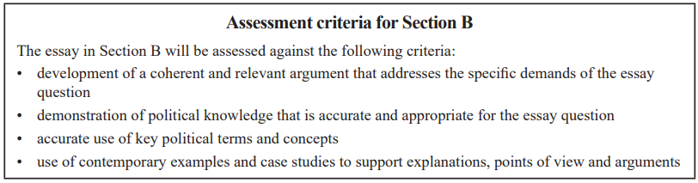

**END OF QUESTION AND ANSWER BOOK**

